SOLUTIONS
ARROWS
Answer: GREEK
Convert each arrow into a horizontal-vertical right-angle pattern as shown in the figure. The starting point of the arrow should be the midpoint of the line segment connecting the endpoints of the two perpendicular sides.
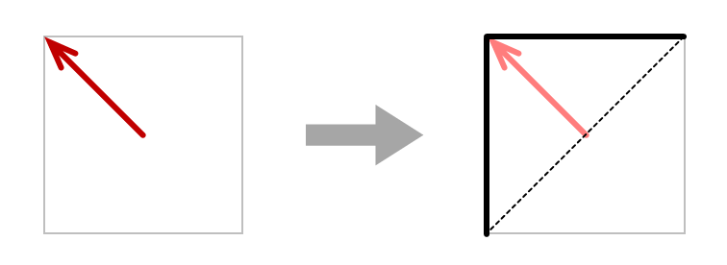
Therefore, we get the patterns below. Above reads ILION, an alternative name for Troy; below we find the answer to this puzzle: GREEK.
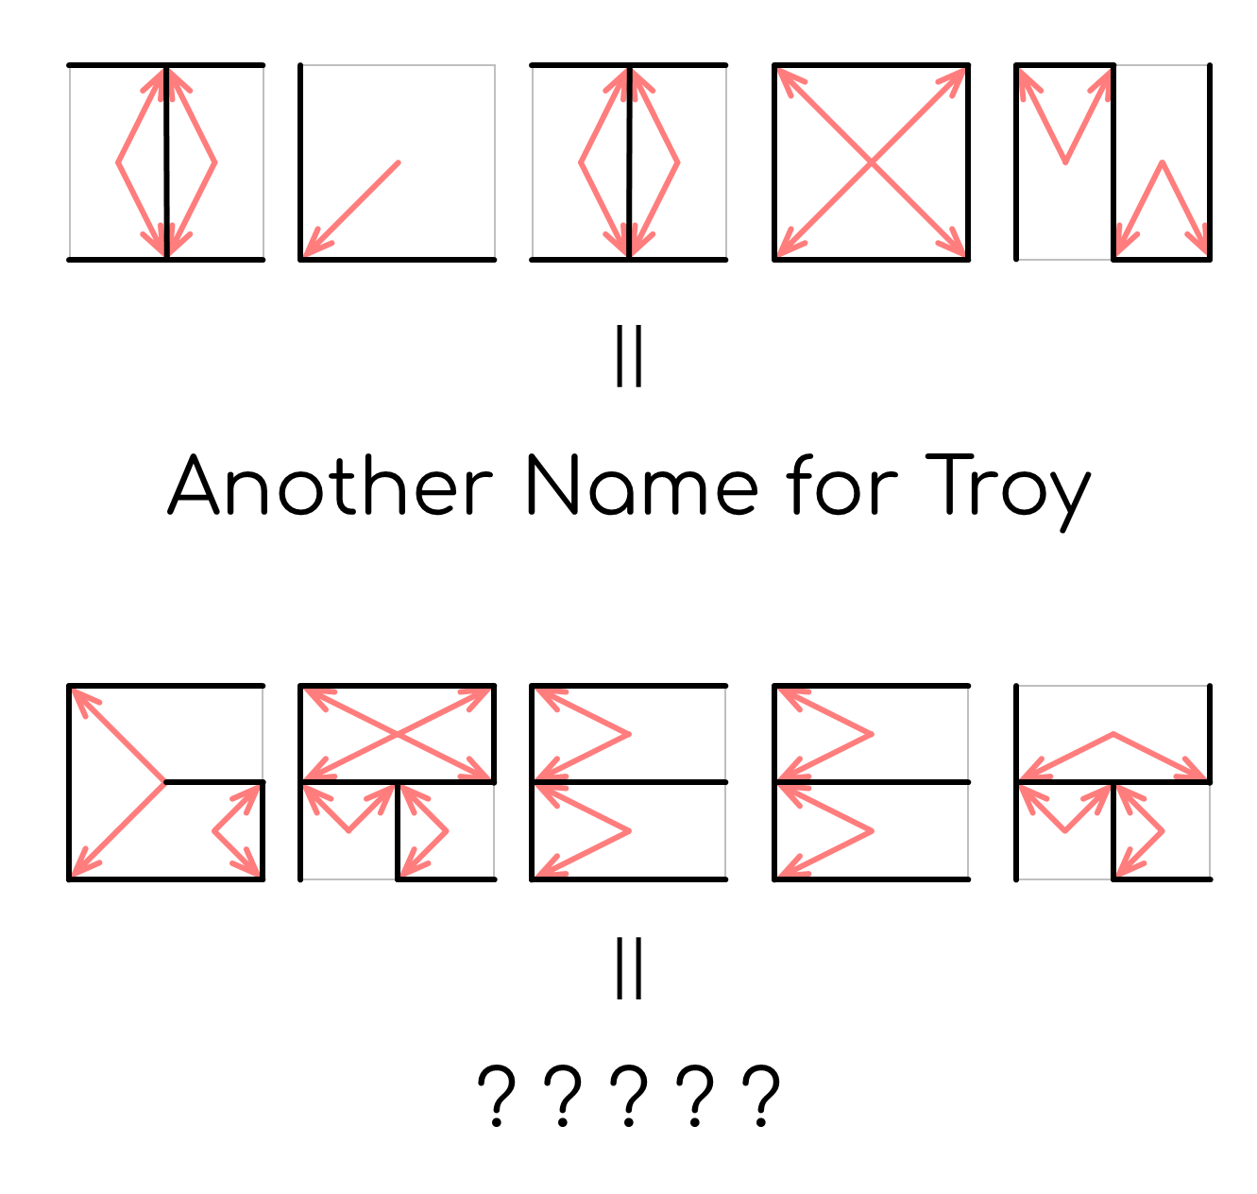
NONOÖBOL
Answer: HONOR
First, we have Α = 4, Β = 2, Γ = 3.
Then, only one arrangement of the possible four can yield a solvable nonogram grid.
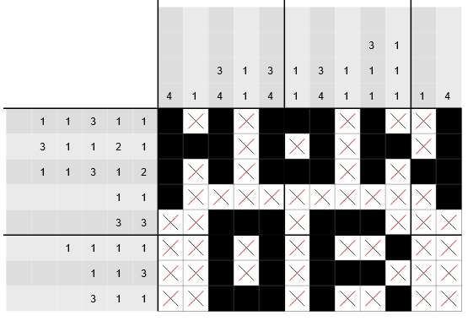
Solving it reveals the answer HONOR.

SLAY THE TROJANS
Answer: MOMENT OF EXCELLENCE
The title “Slay the Trojans” prompts us to remove items related to Trojans from the array.
These words can be categorized into the following types:
- Gods and nymphs: Naiad, Charis, Leto, Eurynomē
- Achaians: Odysseus, Menelaos, Theseus, Euchenor, Lykomedes, Nestor
- Place names in the Iliad: Medeon, Epidauros, Corinth (=Korinth)
- Names unrelated to the Iliad: Fred, Emma
- Randomly selected nouns: Otaku, Xylophone, Engine
- Trojans: Abas, Thoön, Chromios, Echemmon, Hektor, Polyidos, Hypeiron, Antiphos, Elasos, Epistor, Moulios, Charops, Laodamas, Phorkys, Kaletor, Hippothoös
- Computer trojans (trojan horses): Zeus, Emotet, Beast, Stuxnet, Regin, MEMZ
Two points to note: First, “Slay the Trojans” is a pun—the items to be deleted include not only the Trojan people but also computer trojan horses. Second, while Zeus is the name of a god, it is also the name of a notorious computer trojan, so it must be removed as well.
After removing the two categories of words that should be removed, the initial letters of the remaining words, when strung together in order, yield the answer: MOMENT OF EXCELLENCE.

CROSS LÉXI
Answer: HOSPITALITY
The answers to the clues are: Achaians, Agamemnon, Aias, Alphabetical, Ares, Bacchanalia, Grandparents, Oblong, Pantheon, Patronymics, Priam.
The solution to the crossword is as follows:
Using the numbers given to extract in order, we can obtain the answer HOSPITALITY.

DROPCITE
Answer: FATE
The solutions to these dropquotes are as follows. Note that cells highlighted with special colors do not contain original content but represent line numbers composed of “LINE + Roman numerals.”
We get these 4 lines: “She spoke in prayer, but Pallas Athene turned her head from her.” (Line 311)
“The goddess standing behind Peleus' son caught him by the fair hair, ...” (Line 197)
“And the gods went down to enter the fighting, with purposes opposed.” (Line 32)
“Be of good courage now, Diomedes, to fight with the Trojans, ...” (Line 124)
They come from Book 6, Book 1, Book 20, and Book 5 respectively. Using the A1Z26 conversion, the answer obtained is FATE.
EXPLORATION
Answer: GLORY
The first instruction gives DAPHNE.
The second instruction refers to Hera. Following this instruction, we get DPN.
The next instruction refers to the Caeser cipher. By shifting backward 3, 2, and 1 position for corresponding letters we got in the previous instruction, we get GRO.
The next instruction refers to Apollo and Leto, and we should insert the letter L, giving GLRO.
The next instruction makes GLOR.
The final instruction adds the letter Y to the end. Therefore, we get the final answer GLORY.

META
Answer: MĒNIS
First, the arrows are actually the symbol of the first puzzle, which implies a conversion from English to Greek.
Symbol of the puzzle | Answer to the puzzle | Corresponding Greek form
𐀃 | HONOR | TIMĒ
𐀀 | MOMENT OF EXCELLENCE | ARISTEIA
𐀲 | HOSPITALITY | XENIA
𐀠 | FATE | MOIRA
𐀁 | GLORY | KLEOS
Fill in the Greek forms of the words and extract the character at the specified position in Greek alphabetical order, we can get the final answer: MĒNIS.

